|  |  |
| --- | --- |
| WALBERSWICK CREST | **WALBERSWICK**  LOCAL HISTORY GROUP |

**NEWSLETTER NO: 47 February 2015**

**LETTER FROM THE CHAIRMAN**

This newsletter signals changes within the History Group. The committee lost two members, who have left the area: they are Pen Allport and Helen Baxter. I would like to thank them both for their contribution to the Group. We are now looking to try and replace them, to give a balance to the committee and to provide a few more helpers that can be called upon.

Pat Lancaster has offered to edit the Newsletter temporarily with assistance from Julia Reisz. However, we are now looking for a permanent Editor.

**Philip Kett (Tel No: 01502 723800 Answerphone)**

**EDITOR’S NOTE**

Although this is my first attempt at the Newsletter, I have had substantial support from Julia Reisz and have found this invaluable. For anyone wishing to take on this task, there is a great deal of material in the archives that has not appeared in Newsletters before and like me you would have support from other members of the committee. You may prefer an electronic version of the Newsletter sent to you. If this is the case, please let me have your email address; otherwise it will still come through the letter box as usual.

**Pat Lancaster (email:** [**pat@globalchair.co.uk**](mailto:pat@globalchair.co.uk)**)**

**THE SUFFOLK PUNCH TRUST**

Following on from a successful lecture in the autumn, a visit to the Trust at Hollesley has been proposed. The date has not been set yet, but a good time might be between the two local Agricultural shows which this year are being held at the end of May and the beginning of July, in which case some time about the middle of June might fit in very well. We might get a presentation from the head horseman if there are enough of us. There is a café on site for lunches so we could go late morning and have a great day out. If there are enough people wishing to go, a coach could be hired, so please let me know if you are interested.

**Philip Kett (Tel No: 01502 723800 Answerphone)**

|  |
| --- |
| **Dates for your Diary**  Saturday 11 April 2015 Joe Kennedy Junior’s Last Flight by Nigel Walpole & Mick Muttitt  Tuesday 21 April 2015 AGM  Wed & Thurs 6 & 7 May 2015 Test Pit Digging  TBA Visit to Suffolk Punch, Hollesley  Saturday 10 October 2015 EDF Energy Talk on Nuclear Power Stations at Sizewell |

**TEST PIT DIGGING**

This will take place on Wednesday 6th and Thursday 7th May. The aim is to cover as much ground as possible and to examine the unknown history of this village. The pits will be dug with schoolchildren from local schools. The pits are dug in lawns well away from plants, trees and shrubs, the excavated soil sieved and any finds recorded.

At the end of the two days, the hole is then backfilled and the turf replaced; I shall be around all the time to see what is going on and will come in at the end to put right any problems that are left and ram the turf to leave everything tidy.

If you would like to have a test pit dug in your garden, to find out some of the past history of this village, please let me know as soon as possible. There was test pit digging in Southwold and Reydon last year in August and interestingly Walberswick had a better variety of finds.

**Philip Kett**

**THE WESTWOOD MARSH MILL**

A striking landmark on Westwood Marshes, this Mill was built in 1798 and worked as a combined drainage and corn grinding mill. The drainage was achieved through a simple scoop wheel which scooped the water over a raised weir of about 12 inches; the water was then channelled through the marsh wall (Mill Wall) and a sluice out into what became the *“New Dunwich River”.*

At the outbreak of WWII the marshes were flooded by blowing up the junction of the Mill Wall and the section that joins Little Dingle Hill, which enabled the flooding of the Westwood, Dingle and Dunwich Marshes. The sluice at Walberswick was then reversed to contain the water and so flood an immense area of low-lying grazing marsh.

The Mill was then redundant and was used for rifle practice until the West side was completely blown out, exposing the internal woodwork. After the war there was a move to restore the Mill and money was raised to repair the tower, reinstate the sails framework and repair the boat-shaped cap.

Unfortunately during the 1960's the Mill was set on fire, leaving it in its present ruinous state.

Recently there has been a move by Natural England to repair the Mill brickwork, and a committee was formed to look at the possibility of repairing the brickwork and adding a lookout or observation point at the top; information boards showing the mill and its environs as well as the wild life were also proposed. This plan had got well under way, but unfortunately Natural England has had to reduce staff, so the scheme has been temporally shelved.

**Philip Kett**

**FOR KING AND COUNTRY – WORLD WAR 1 IN WALBERSWICK**

*On the 4th August 1914 the United Kingdom entered “The Great War” (WWI as it later became), a decision that for whatever the reasons would change the British way of life forever. Just over four years later with millions either dead or physically and mentally scarred the country struggled to deal with the massive loss of sons and husbands. In the UK almost a million people died as a result of the war (probably more counting post-war deaths). This represented just over 2% of the entire population and, of course, a much higher percentage of young men. Every city, town, village and probably street in the country was touched. This was an unprecedented experience. One way that the country and communities dealt with this was through the erection of war memorials.*

***This article provides some details of the men from Walberswick who served in WWI using the names recorded on the Walberswick memorials………***

*Peace came at last in November 1918. Marshall Ferdinand Foch, a French soldier, who accepted the German request for an armistice later declared after the Treaty of Versailles: “This is not a peace; it is an armistice for 20 years”. Sadly, he was only 65 days short of what happened. The Walberswick Peace Committee distributed Bibles in 1919 to the children of the village after the “war to end all wars”. How could they imagine that 20 years later, some of those very children would be fighting and dying due to the unfinished business produced from the peace negotiated in 1919.*

The web makes articles easily available to a wider audience. We wanted this article to be “searchable” (try entering WWI + Walberswick into Google search and see if this is found).

We are keen to get more information on the men listed and update the article for 2018. We have already had two responses that add human interest to what could just be a list of names and dates. Please do send in any information you have on the men and families mentioned – we want their stories. You can do this by email to [johnrenglish@tiscali.co.uk](mailto:johnrenglish@tiscali.co.uk) or using good, old-fashioned pen and paper to the WLHG archivist – Pat Lancaster, Highfield, Leverett’s Lane, Walberswick, Suffolk IP18 6UF.

**So, if you do not already know:**

Open up your web browser and go to <http://walberswick.onesuffolk.net/>

In the left-hand column, select “Walberswick Local History Group”

Then click on “World War I”

You may also like to view other articles/items on the website relating to WLHG.

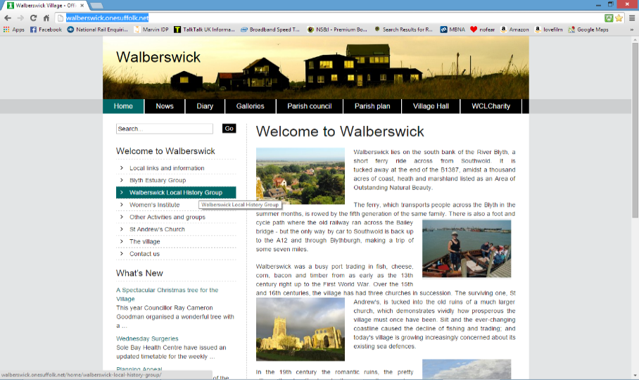

**John English**

**WALBERSWICK IN THE 1930S: A NOTE ON CLASS**

When my father first came to Walberswick in 1932, he was amazed when a local man in the public bar at the Anchor took him aside and told him: “Mr. Coppard, there are only two kinds of people in Walberswick - the nobs and the poor”. And in those days this was perfectly true. The public and saloon bars exemplified this: no village chap would dream of entering the saloon bar, where the “nobs” sat drinking their gins and whiskies; the public bar was where darts and shove-ha’penny were played and there was a good deal of noisy local banter. As a writer, my father loved the public bar: he went for a pint every day at noon to listen to the talk.

At that time the village was almost feudal in character, and the local landowner, Sir Ralph Blois, was treated with a deference that would seem extraordinary today. From time to time he would be driven through the village in an open car, and men would doff their caps as he went by. He owned all the land round the village, except for the common (as the family does to this day) and his gamekeepers kept a very tight control over it: if you strayed into an enclosed area, you would be ordered off in no uncertain terms. Sir Ralph was also landlord of many of the small cottages in the village which were rented to local folk.

The “nobs” all had living-in servants: an electoral roll from that time shows people with different surnames living in all the larger houses. In those days domestic service was the commonest opportunity for girls leaving school – indeed, often the only one. Boys in the village would either become fishermen like their fathers or work on the land: in those days (before agriculture became largely mechanised) farms employed a good many people. There were also many large gardens, often with tennis courts, so working as a gardener was a real opportunity. Boys with a mechanical bent were able to find work in local garages or become chauffeurs to the wealthy.

Summer brought a number of changes. Some people moved to huts by the river for the season, so that they could rent their homes to visitors: my parents did this for a couple of summers, staying in the Studio. Many village people also offered bed-and-breakfast accommodation: often this would be occupied by the children of wealthy parents and their nannies, who had been sent for a healthy seaside holiday while the parents went to more glamorous places abroad. There was one family where the parents went to Monte Carlo each year. The beach was a somewhat middle-class enclave: one didn’t see village people on it very much during the day.

Schooling was another great divide. My parents (strapped for money) eventually sent my brother and me to the village school – almost unheard-of in those days; very few parents who regarded themselves as middle class would have dreamt of such a thing. Parents who did not send their children away to boarding school sent them to Eversley in Southwold – typical of the rather undistinguished prep schools that existed mainly for class reasons. When Mr Reynolds, owner of the village shop, tried to send his son Peter to Eversley, he was turned down because he was “in trade”.

At the village school, children that the head teacher (Mrs Piper) considered bright would put in for “The Scholarship”, the forerunner of the 11-plus: those that passed proceeded to the Sir John Leman School in Beccles. The board with the successful names is now in the Village Hall. The rest went to Reydon School where, in a most enlightened move by the local authority, they were issued bicycles so that they could ride to school. These bikes were painted white and were much prized: many children would not otherwise have had a chance of a bicycle. Children left Reydon at the age of 14 – another great divide.

The poor were really poor, in a way that you do not see today. Families tended to be large, and wages were low. Many of the children wore heavy leather ankle boots bought for long wear, winter and summer: this was a contrast to the sandal-wearing visiting children who had come for holidays. There were no school dinners in those days, and some children looked as though they did not have a whole lot to eat – so the allotments were of great importance to working families and taken full advantage of. And of course rabbits were everywhere, and could be shot and eaten.

The working heart of the village was down by the harbour, where the ferry went back and forth across the Blyth during the day. This was where the fishermen worked, dealing with the catch and also mending their nets. But also in that area there were a number of artists’ studios, which were occupied mainly in summer, and so one frequently saw painters setting up their easels amid the general bustle of the working folk.

The cottages in the neighbourhood of the Green were all occupied by working people; the “nobs” all tended to live further up the village, in the large houses in Millfield Road or Leverett’s Lane. Mr Reynolds’ grocers shop was also on the Green, which was a busy central area. On summer evenings the village lads played football there; meanwhile the “nobs” had their tennis parties – then as now tennis was a middle-class activity. Also very popular in the summer was the Punch and Judy show, which appeared most days in the holidays.

There were council houses in Church Lane, which had no bathrooms: at that time they were not thought necessary for working people! Most of the small rented cottages were also without bathrooms, and children would be bathed on Saturday night in a tin bath in front of the fire, ready for Sunday, when they would wear their best clothes and told to keep them clean. Sunday brought another division, when most of the village folk attended chapel, while the “nobs” favoured the church.

In short, this was a village where everyone had an allotted place, and nobody would have dreamt of moving outside their particular niche. With the coming of World War II, all that was to change. The young men were called up, mostly into the Navy or the Merchant Navy; women had the opportunity of working in factories, joining the Forces or the Land Army, and for the first time earning money of their own outside the domestic sphere. The big houses no longer had servants living in; and the large gardens with tennis courts were hard to maintain. Gradually the smaller houses were sold off as holiday homes, and many young people who had been born in Walberswick had to find homes and livelihoods elsewhere.

**Julia Reisz**

**WALBERSWICK UNITED FOOTBALL CLUB**

Although there were previous Football Teams in the Village, this Club was formed in August 1987 and affiliated to Suffolk County FA with Robert Wythe as President, Ray Rose as Manager and Les Watson as Chairman. Members such as Alison Fisk gave invaluable support from the beginning. It celebrated its formation by being beaten 18-0 by Wenhaston in a friendly match in October of that year!

In 1988 it joined the Sunday Morning League, and in six years had risen from Division II (Eleven) to Division 4 (Four) winning the League Championship in May 1995 – a remarkable achievement.

At the outset, the team was formed almost exclusively by players from Walberswick, however as players left or had to drop out for other reasons, that could not be maintained.

Here is a photograph of the team around that time:



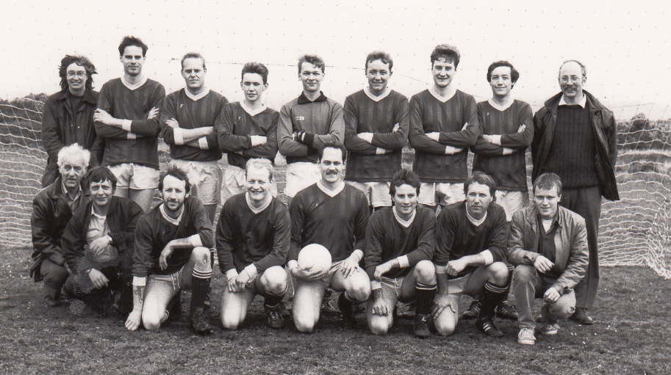



**Pat Lancaster**

**(With thanks to Ray Rose, data from an article by Robert Wythe and the Woodcraft family)**

**E&OE**